The order in which your move/upgrade needs to be completed is:

Phase 1: Consolidating Surround Servers (removing mainlines from one server and adding them to another)

Phase 2: Moving to Windows in your current version of Surround and TestTrack

Phase 3: Upgrading to the current version of Surround and TestTrack

What exactly is your goal by consolidating the Surround servers? If your goal is to simply have all your information on what Surround server than the only way to do this is to remove the mainline branches from one Surround server and add them to another. Instructions for doing so are as follows:

1. Launch the Surround SCM Client and connect to ‘SCM Server 1’
2. Select the mainline branch ago go to Tools > Administration > Remove Mainline Branch

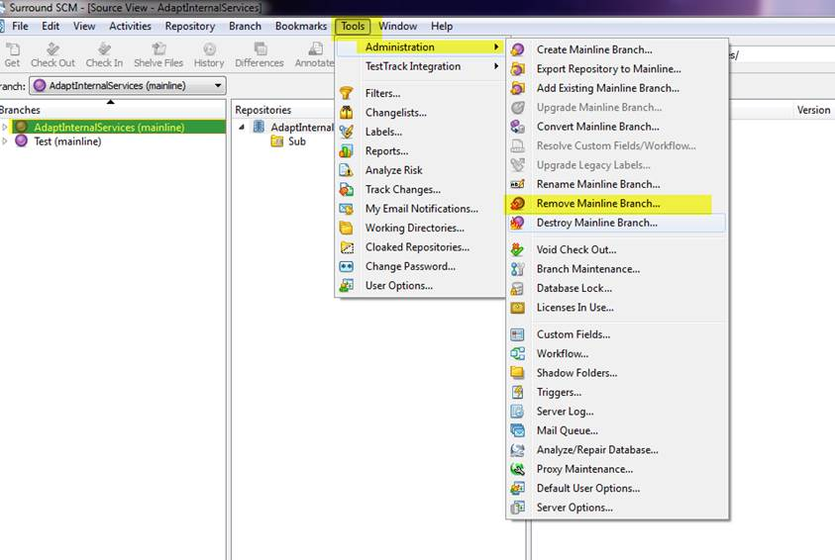

1. Click “Yes” on the prompt

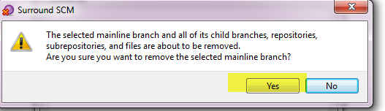

1. Follow these steps for each mainline branch on ‘SCM Server 1’
2. Once you have removed all the mainline branches on ‘SCM Server1’ go to File > Connect to Server and change the ‘Server’ location to ‘SCM Server 2’
3. Go to Tools > Administration > Add Existing Mainline Branch

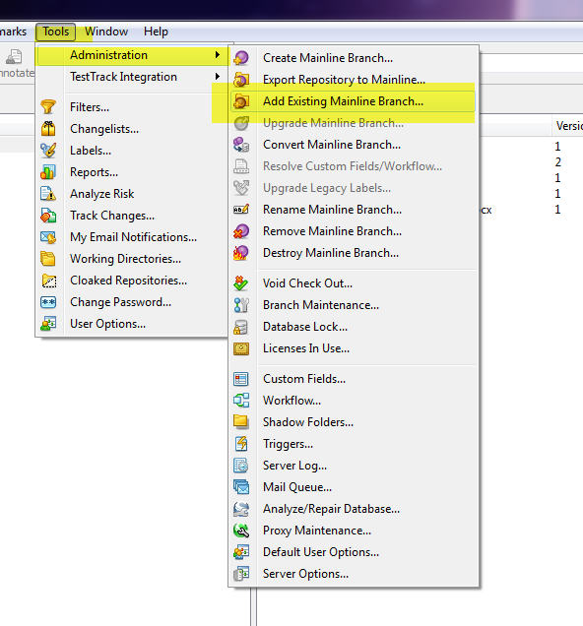

1. Select the mainline branch and click “Ok”
2. Follow these steps for each mainline you removed from ‘SCM Server 1’

Phase 2: Once you have added all the mainline branches from ‘SCM Server 1’ to ‘SCM Server 2’ we will provide to the next phase of backing up your databases and moving to Windows.

* The following link provides step by step instructions for backing up Surround SCM databases - [Backing up Surround SCM Databases](http://www.seapine.com/knowledgebase/index.php?View=entry&EntryID=687)
* As for backing up your TestTrack databases  - which database type are you using? I believe it is TestTrack Native so those instructions are below
* The instructions for native are:
  + Stop the TestTrack Server.

Copy the contents of the TTServDb directory on the TestTrack Server computer. Only copy subdirectories if you are using TestTrack 2011.2 and earlier and want to back up projects at the same time. Following are the default locations:

* + 1. Windows—C:\Program Files\Seapine\TestTrack\TTServDb
    2. Mac OS X—/Applications/TestTrack/TTServDb
    3. Linux—/var/lib/TestTrack/TTServDb

Restart the TestTrack Server.

* You will also need to take a backup of the License server database as well.
  + Stope the License Server Service
  + If the database is also native you will copy the LSServer.db file from the LicenseServDb directory to the new location. The file will be located here: Linux—/var/lib/splicsvr/LicenseServDb
* Once you have taken all of the above backups you can install TestTrack, the License Server, and Surround on your Windows machine.
* You will also need to create your empty MS SQL databases. You will need a total of 4
  + - One for License Server
    - One for TestTrack Server
    - One for TestTrack Projects
    - One for Surround Server
  + Once you have the databases created you will need to create 4 ODBC connections to connect to each database. Instructions for doing so can be found here: <http://www.seapine.com/knowledgebase/index.php?View=entry&EntryID=376>

I have your version of Surround as 2012.0.0 – here is the download link –32-bit- <http://downloads.seapine.com/pub/software_old/sscm2012x/sscmwin201200install.exe> - (License Server is included in either installer. If you install it once just uncheck the box in the next installer)

* + . To determine this you can launch the Surround client and go to Help > About Surround SCM and the following box will tell you which version you are running
* ***When you install Surround make sure you elect to download PostgreSQL as well***
* Once you have installed Surround the following link gives instructions for restoring your PostgreSQL databases: <http://www.seapine.com/knowledgebase/index.php?View=entry&EntryID=718>
* Once you have restored your PostgreSQL database in Surround you can go to Tools  > Administration > Server Options and click “Convert” as depicted below:

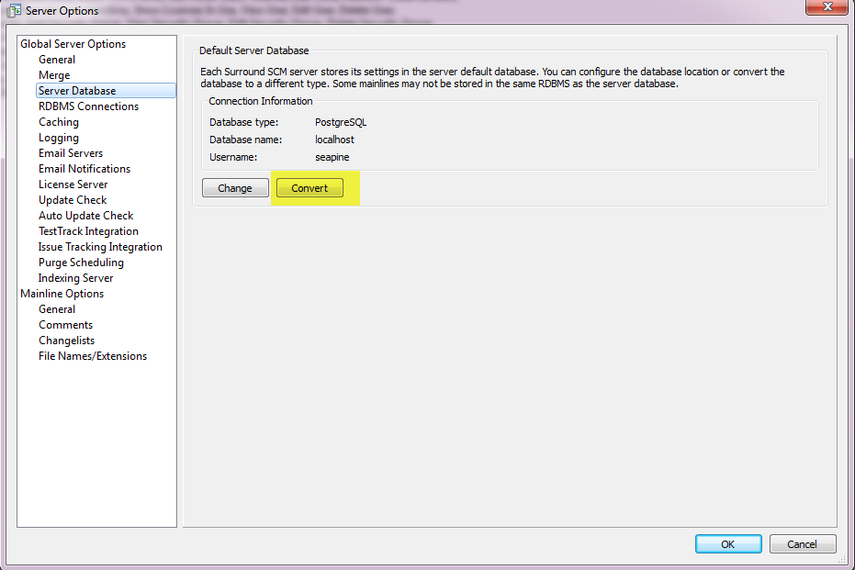

* Select “ODBC – SQL Server” as the connection type, select the appropriate data source name

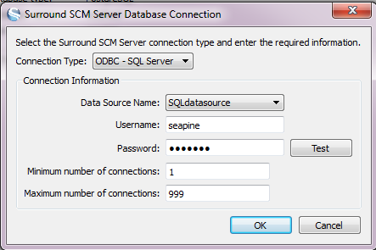

* Fill out the username and password information for the SQL Server account that has administrative privileges (usually a system administrator account) then click ok twice to get out of the menu

Installing TestTrack

* Please provide me with the TestTrack version you are current using so I can send you a link for the download
* In the TestTrack installation opt to **not** start the TestTrack Server
* Place the copy you took from the linux machine of the “TTServDb” directory into the TestTrack directory (you can remove or rename the directory that is already there)
* Start the TestTrack Server
* Launch the TestTrack Admin Utility and verify you are able to login
* Click “Projects” and make sure the status column for all your projects says “Loaded Successfully”
* Close out of the projects menu and click Server Options > Server Database and click “Convert”
* Select the data source name you created for your *TestTrack Server* and fill out the username and password information for the SQL Server account that has administrative privileges (usually a system administrator account)

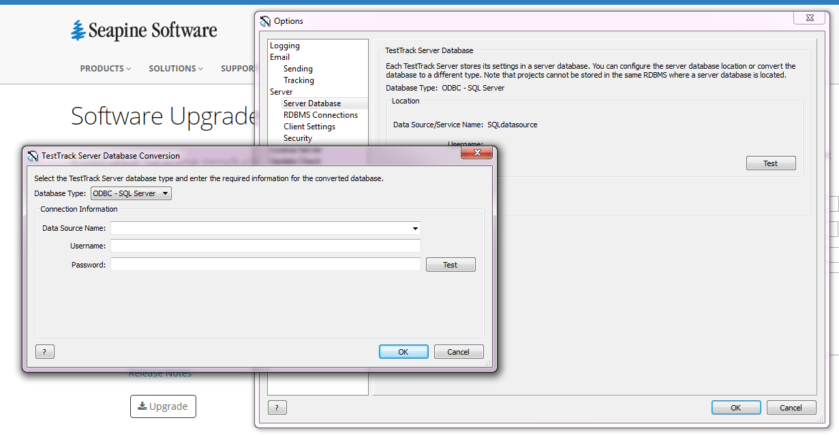

* Click “Ok” twice
* In the ‘Options’ menu click RDBMS Connections > Add
* Select the data source name for your TestTrack projects and fill out the username and password information for the SQL Server account that has administrative privileges (usually a system administrator account)
* Click ok out of this menu and select “Projects”
* Select all the projects and click “Inactivate”

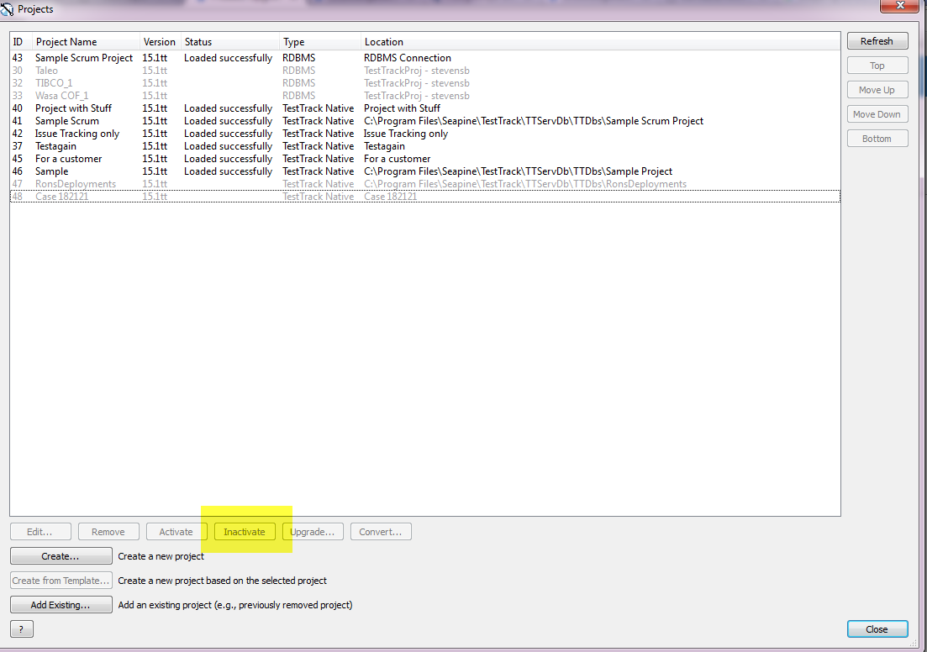

* Select a project and click “Convert” select the Connection that corresponds to your TestTrack projects and give the project a new name and directory name then click “Ok”
* A dialog box will pop up asking if you want attachments to be stored in the database itself or in the “Attach” folder in the TestTrack directory. This is up to you.
* Click “Yes” to begin conversion
* Repeat these steps for each project you have

Phase 3: Upgrading

* Download the current version of TestTrack (License Server is included in either installer. If you install it once just uncheck the box in the next installer) and Surround. You can find them here: <http://www.seapine.com/support/upgrades>
* All of your settings will remain the same.
* Login to Surround and verify you are able to select files from each mainline branch as they are automatically upgraded
* Login to the TestTrack Admin Utility and select “Projects”
* Select all the projects and click “Upgrade”
* Once the upgrade is complete you will see “Loaded Successfully” in the status column for each project.

Have a user login to the TestTrack Client to verify they are able to get into the projects.

If you run into any issues during this migration/conversion/upgrade please let me know